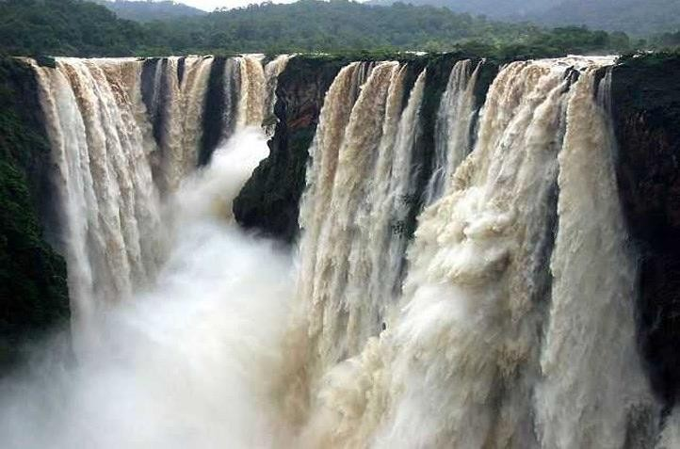

**Karnataka Tourism**

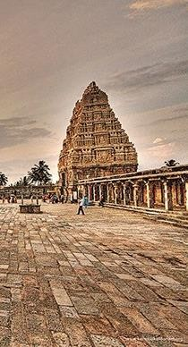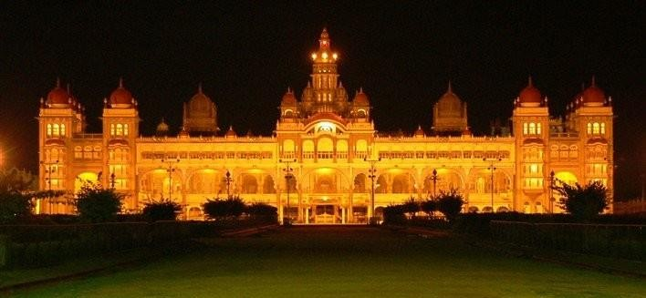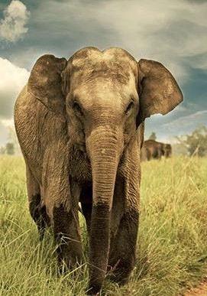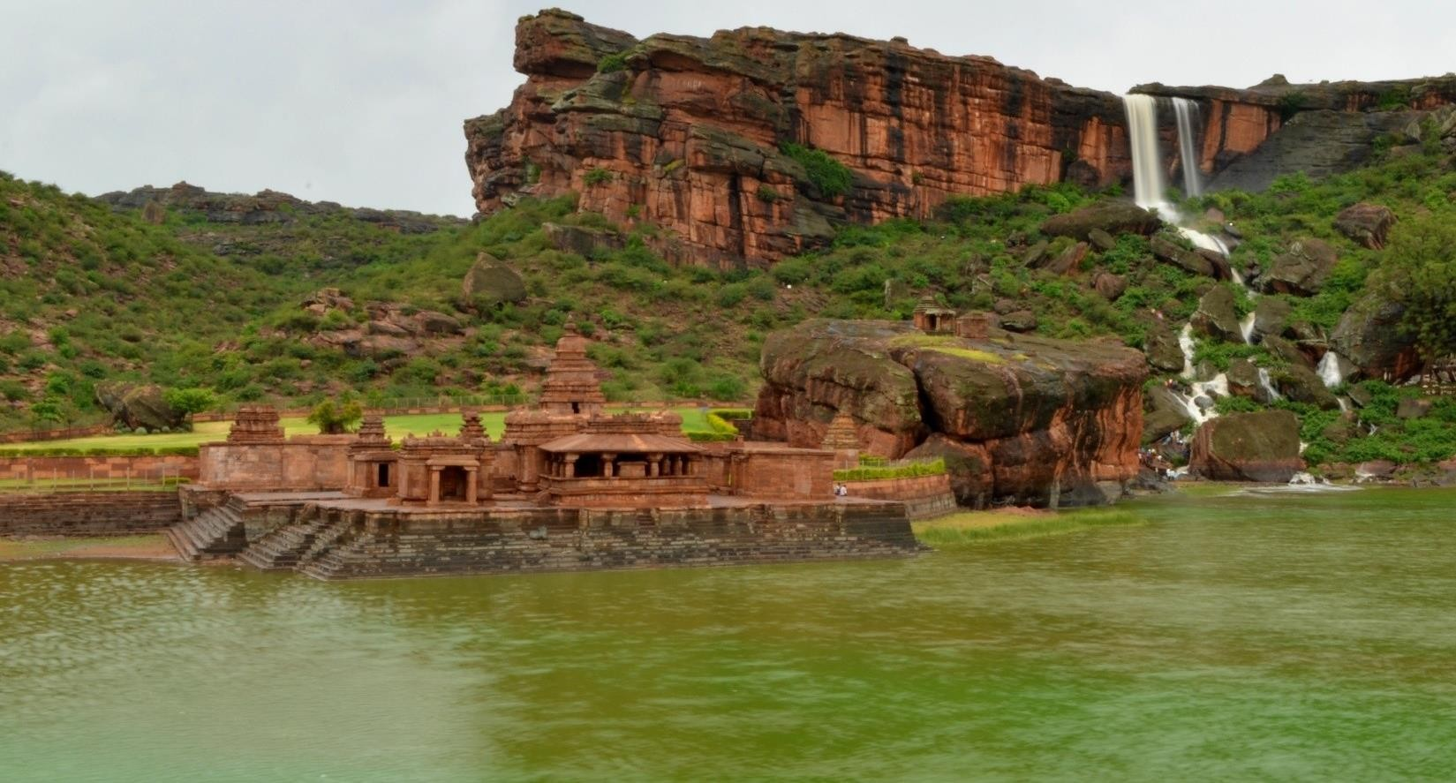

#### Karnataka Overview

* Ranks 4 in India in tourism
* Largest number of tourist destinations in India
* Coorg won an award for being India’s Favourite Emerging Tourist Destination
* ₹700-crore worth tourism investment at the 38th edition of Pacific Asia Travel Association Travel Mart (PATA)
* Mysore, popular tourist hub, exhibits an influence of the Raj era
* Hampi Utsav celebrates the grandeur and elegance of the Vijayanagar era
* More than 100 million tourists in the last five years
* 25 wildlife sanctuaries and five national parks
* Nearly 5.35 lakh tourists,(including foreigners) visited Hampi during 2016-17
* Rough Guides Magazine of England has reported stating that Karnataka is one among the Top 10 Valuable Tourist destination in the World

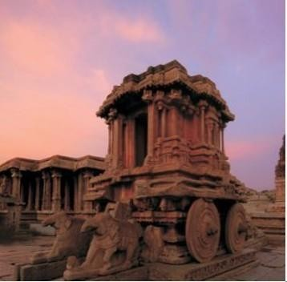 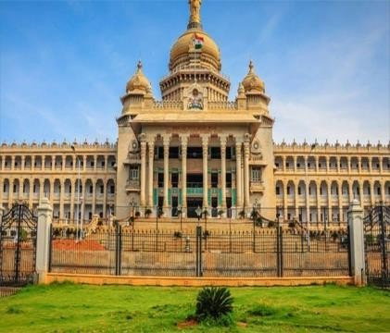 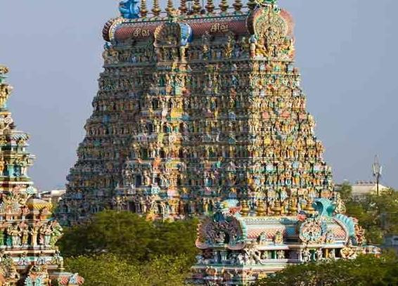

###### Heritage Tourism City Tourism

**Punith Yathra**

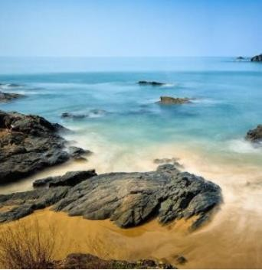 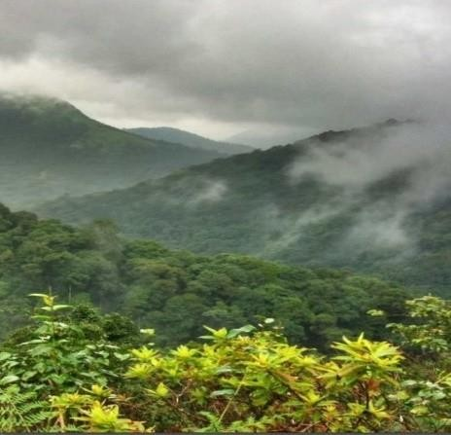 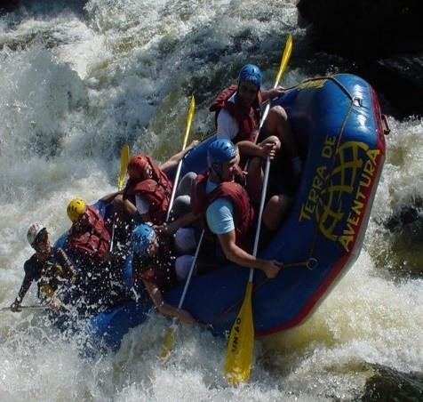

###### Beach Tourism

**Nature Tourism**

**Adventure Tourism**

#### Karnataka- Tradition

Culture of Karnataka is so vibrant that it adds new flavour to its very existence. The local customs, dances and practices add new vibe to the state. It is a state of distinct art & culture with diverse linguistic and religious ethnicity. Yakshagana, a classical folk play, is one of the major theatrical forms of Karnataka. Both Hindustani and Carnatic music are famous. Mysore painting is an important form of classical South Indian painting. It is known for elegance, muted colours, and attention to detail.

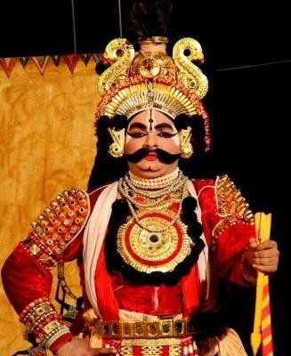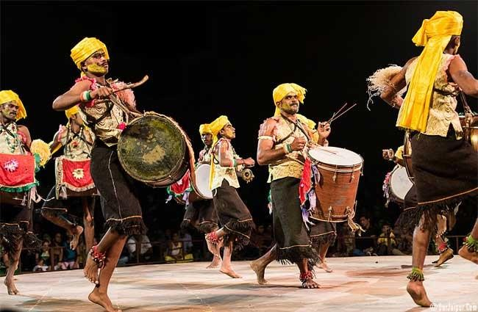

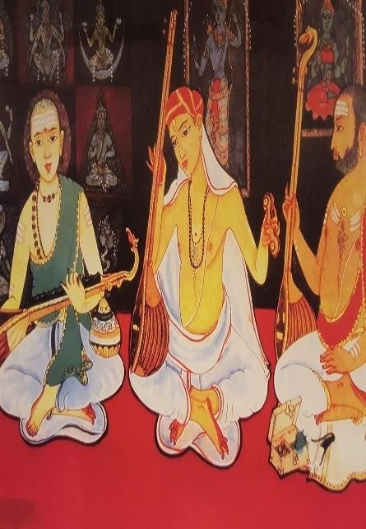Karnataka’s cuisine includes a wide range of vegetarian and non- vegetarian dishes that reflect influences from the neighbouring regions and communities. It is characterized by distinct textures, flavours and taste. The state’s vast culinary repertoire encompasses the earthy and unique flavours. State has a rich culinary heritage.

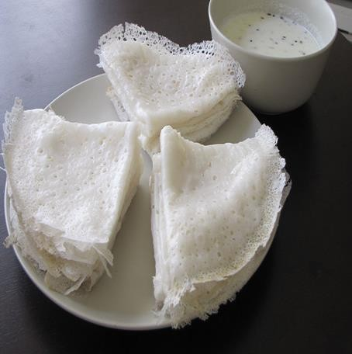Regional food habits broadly differ depending on locally available ingredients.

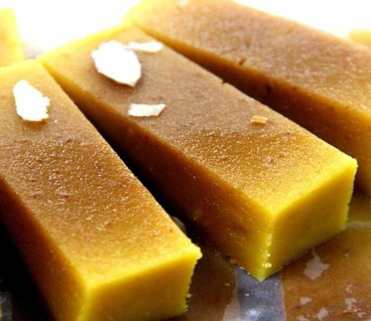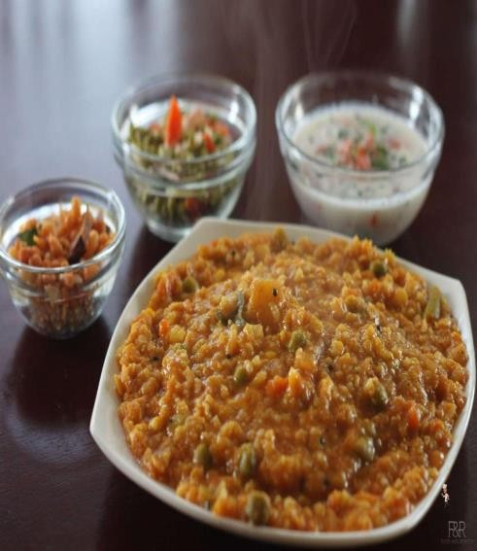

**Karnataka- One State, Many Worlds**

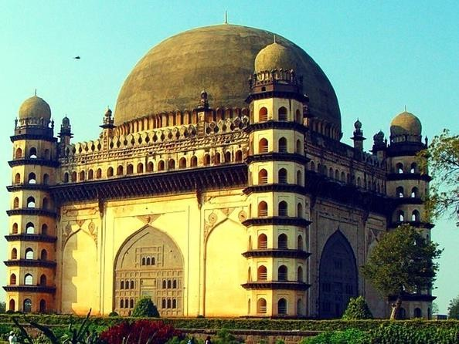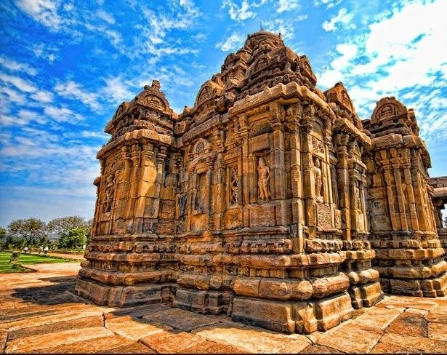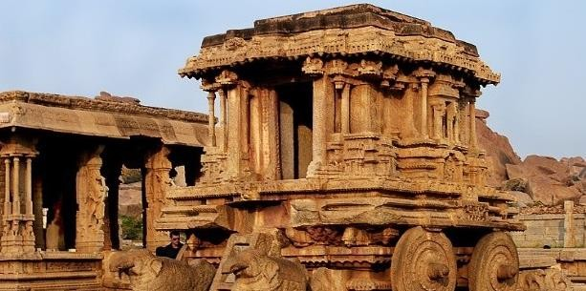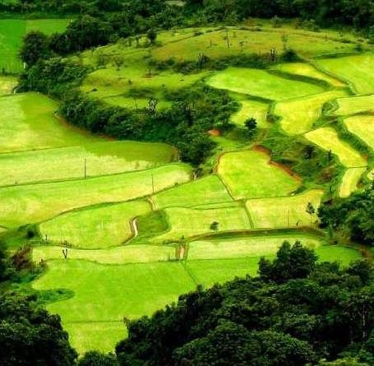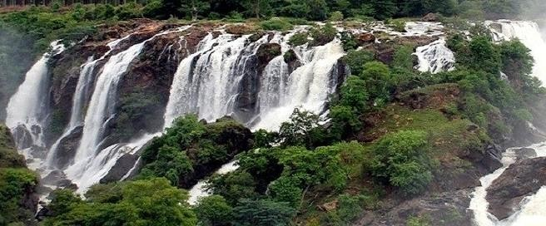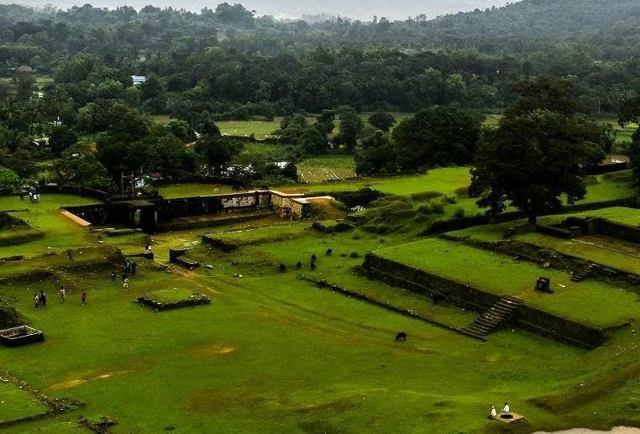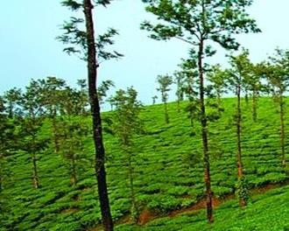

**Jog falls**

* Gokak Falls
* **Coorg**
* Kodachadri
* **Mulliyana Giri**
* Agumbe
* **Nandi Hills**
* Kudremukh
* **Chikmagalur**
* Kemmanagundi
* **Shivanasamudra**
* **Hebbe Falls**

## Nature

#### Karnataka- One State, Many Worlds

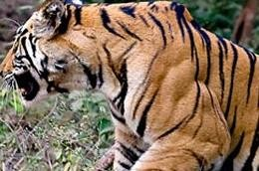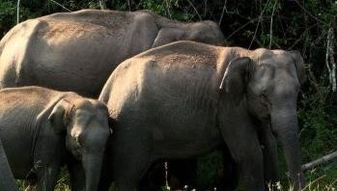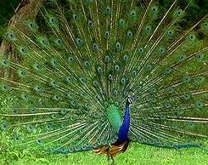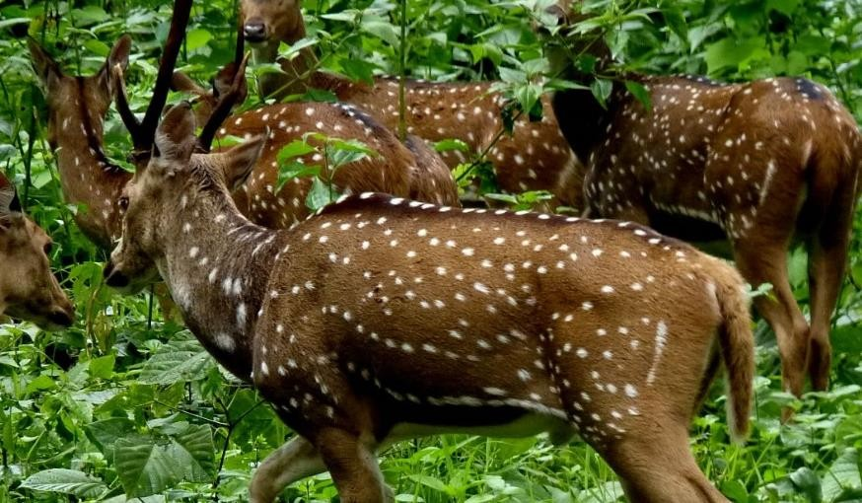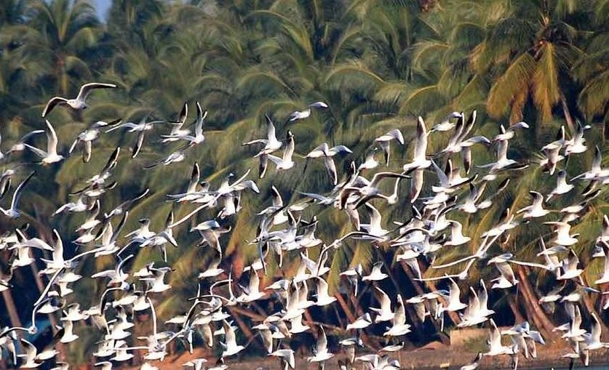

* + Dandeli
  + **Bandipur**
  + Bannerghatta
  + **Dubare Reserve Forest**
  + Ranganathittu Bird Sanctuary
  + **Adichunchangiri Bird Sanctuary**
  + Bhadra Wildlife Sanctuary
  + **Nagarhole**

**National Park**

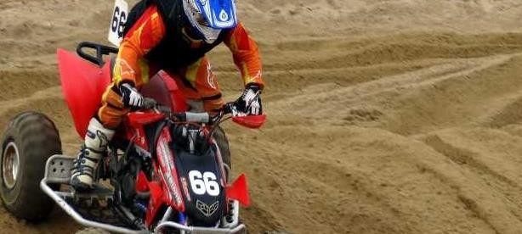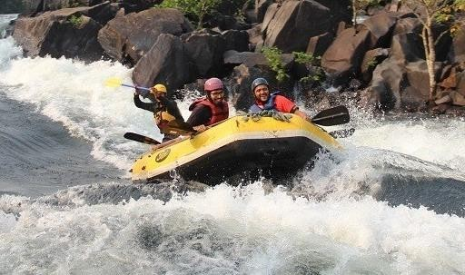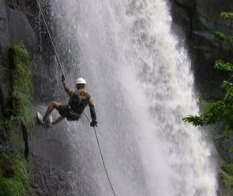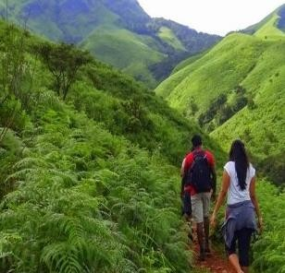

## Wild Life

**Adventure**

**Karnataka- One State, Many Worlds**

**Pilgrimage**

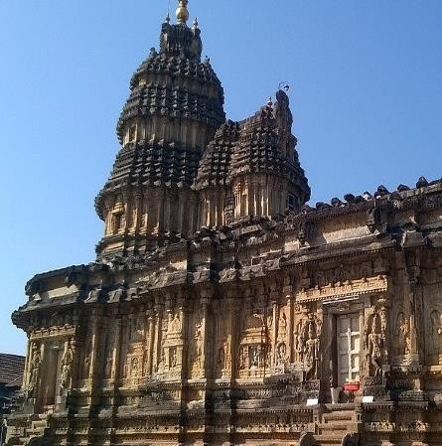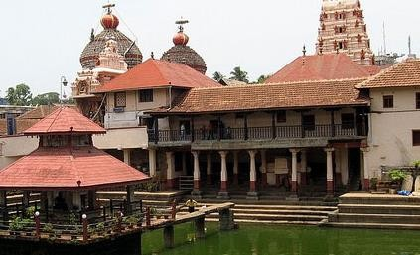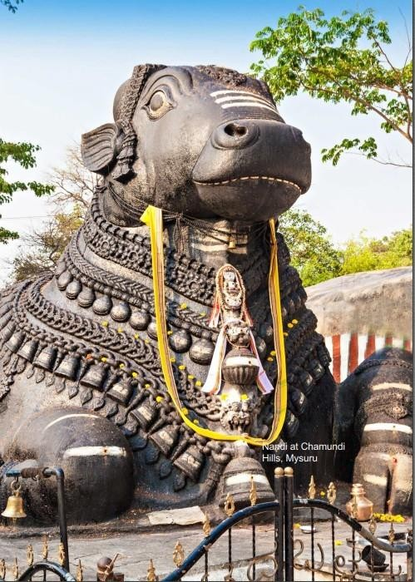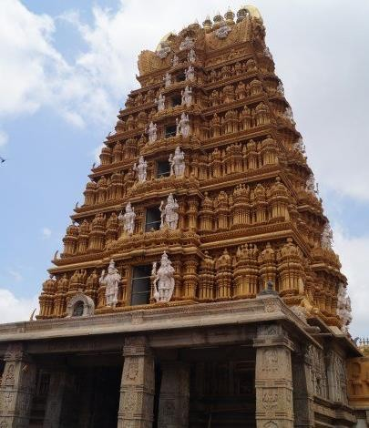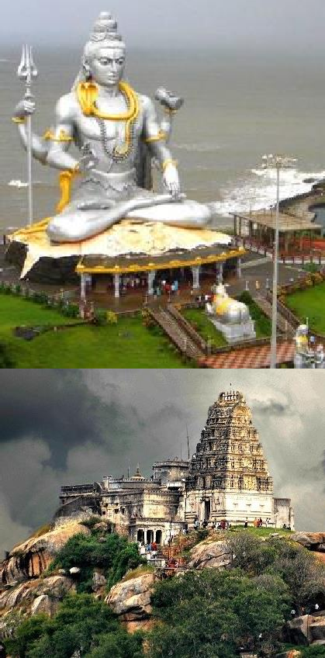

* **Gokarna**
* **Murudeshwar**
* **Udupi**
* **Dharmasthala**
* **Sringeri**
* **Kollur Mookambika**
* **Kukke Subrahmanya Temple**
* **Melukote**
* **Horanadu**

**Annapoorneshari**

* **Ghati Subramanya**
* **Kotilingeshwara**

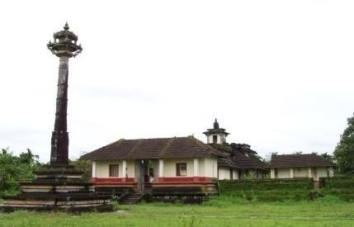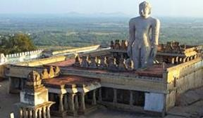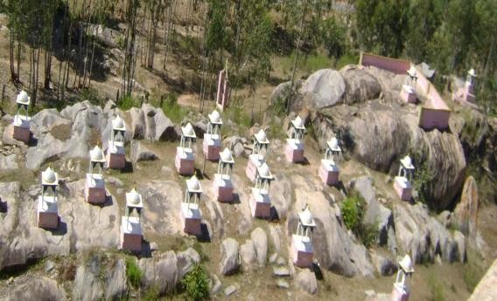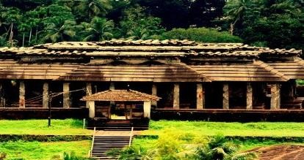

* **Shravanabelagola**
* **Karkala**
* **Venur**
* **Gommatagiri**

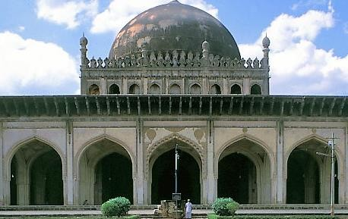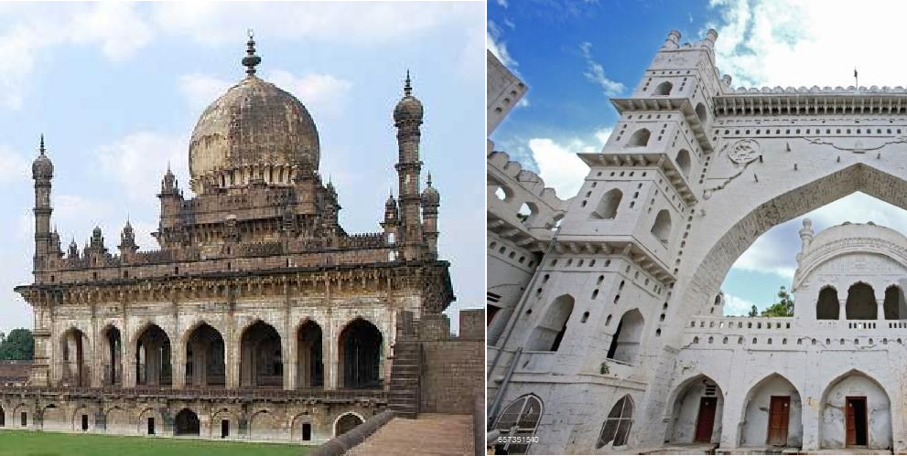

* **Hazarat Tawakkal Mastan**
* **Jama Masjid**
* **Zanana Masjid**
* **Ek Minar Mosque**
* **Khawaja Bande Nawaz Durgah**

#### Karnataka- One State, Many Worlds

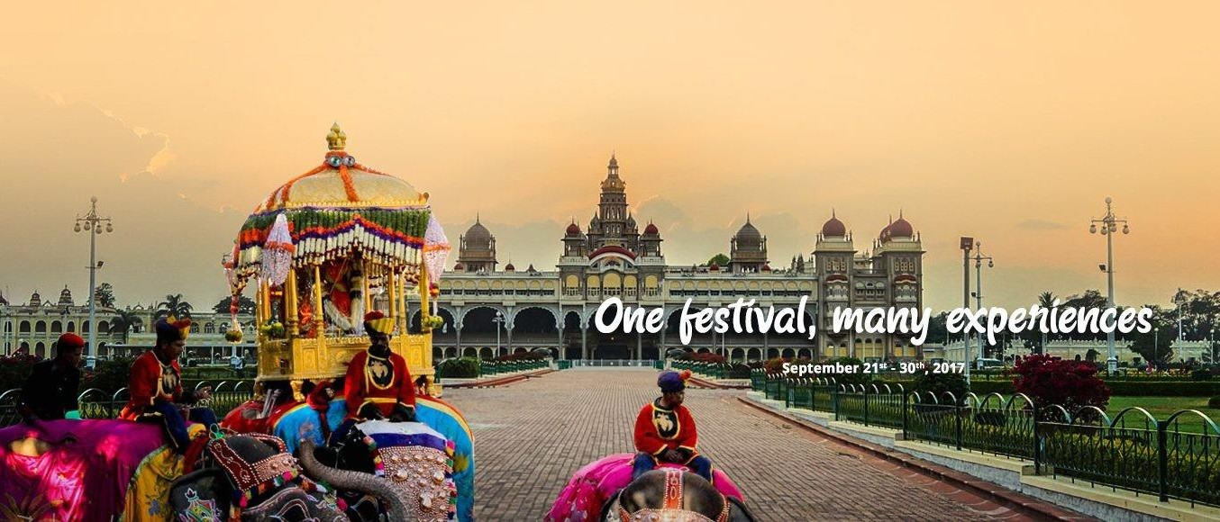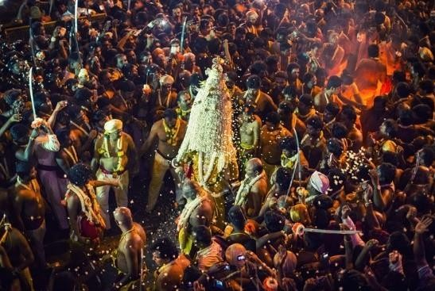

**Mysore Dasara**

Mysore Dasara is the state festival of Karnataka. It is a Royal Festival Celebrating victory of Truth over Evil. ‘’Were royalty, art & culture meets. Celebrating the tradition for 407 years, were goddess is seated on the golden throne with elephants in the grand procession. Where all come together to revel the past, experience the present & remember it for future, 133 year old Monument will tell an incredible story of Mysore Dasara’’. Mysore is an enthralling destination for travelers, especially during Dasara.

**Bangalore**

**Karaga**

Bengaluru Karaga is one of the oldest festivals celebrated in the heart of Bengaluru. It is a well-known tradition of 'Vahnikula Kshatriyas' community in southern Karnataka. It is believed that Draupadi, the Pandava's wife, took the form of Shakthi devi, she created a huge army of soldiers called the Veerakumaras for defeating Asura. Karaga Draupadi is worshipped as an incarnation of Adiparashakti and Parvathi

#### Karnataka- One State, Many Worlds

**Hampi**

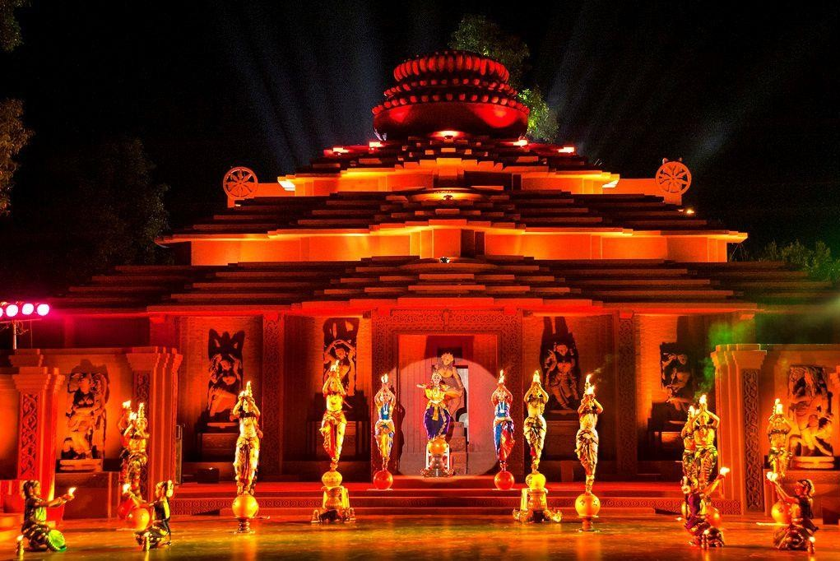

**Utsav**

The largest festival at Hampi. It is a cultural event of UNESCO World Heritage Site, Hampi, presenting elephants, as well as local lads and horses wearing spectacular outfits pointing out military fashion of the Golden Era.The grandeur and elegance of the Vijayanagar era is almost brought back to life, through these festivities. It is scheduled for 3 days during the first week of November. The celebrations typically packed with shows of music, dance puppet shows fireworks and a pomp procession as the grand finale showcasing the cultural richness of the place.

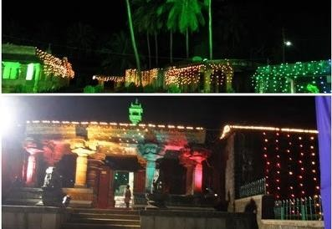

**Kadambotsava**

Kadambotsava is the famous cultural festival of Banavasi (Uttara Kannada District). It is held every year. During the event, artists from different places in South India showcase their music, dance and art forms. Kannada literature ‘Pamapa Award’ will also be presented on the occasions. Priority given for young talents in cultural programmes

#### Karnataka- One State, Many Worlds

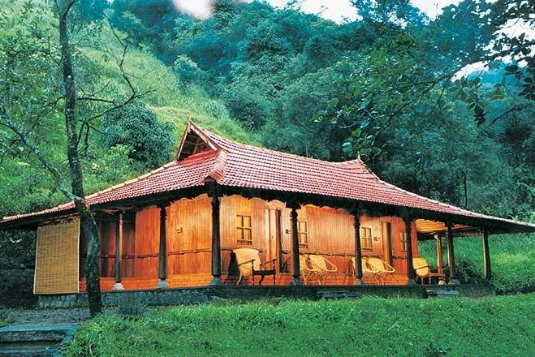

**Bangalore**

**Karaga**

**Jungle Lodges**

**/Resorts**

Jungle Lodges and Resorts (JLR) is a responsible wildlife & eco tourism company with a strong commitment to use tourism as a genuine tool for conserving the environment & wildlife also educates people by letting them experience wildlife and fragile habitats. JLR's resorts and camps are located in some of Karnataka's ecologically sensitive yet amazing natural destinations. JLR offers various wildlife viewing and outdoor activities as part of its packages like jeep safaris into the forests, elephant rides, boat and coracle rides, guided treks, white-water rafting, kayaking, canoe tours, elephant interactions, water sports, snorkelling, para-sailing etc.,

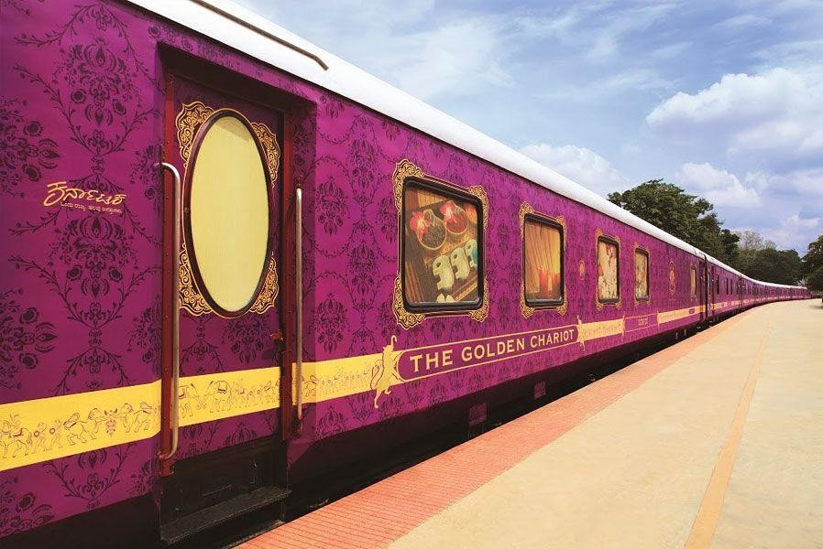

**Golden**

**Chariot**

The only luxury train in South India, "Golden Chariot" offers an insight into treasure trove of archaeological wealth, abundant bounty for wildlife seekers and a kaleidoscope of culture. Designed & operated on the lines of World famous Palace On wheels Train Tour. It is a Southern Splendor. It offers luxuriously furnished Air-Conditioned Saloons of 4 sleeping chambers(Cabins),Two Dining Cars, One Bar Lounge ,Business Centre, Mini Gymnasium & Ayurvedic Spa

**Code**

<html>

<head>

<style>

a{

position: relative;

display: inline-block;

padding:25px 15px;

margin:20px 10px;

color: #FEFB03;

text-decoration: none;

text-transform: uppercase;

transition: 0.9s;

/* letter-spacing: 2px; */

overflow: hidden;

margin-right:20px;

}

a:hover {

background-color: yellow;

}

.top

{

background-color:black;

}

.hover:hover{

background-color:#D5EFFF;

}

h2

{

color:black;

}

.bottom{

background-color:black;

border-radius: 10px;

}

.tbottom{

background-color:#D5EFFF;

border-radius: 10px;

}

</style>

</head>

<body>

<div class="top" >

&nbsp&nbsp&nbsp&nbsp&nbsp&nbsp&nbsp <img src="logo.jpg" alt="Logo" style="background-color:white; padding:10px;border-radius: 10px; margin-top: 5px;margin-bottom: 5px; height:100px; border:3px solid lightgrey">

&nbsp&nbsp&nbsp&nbsp&nbsp&nbsp&nbsp &nbsp&nbsp&nbsp&nbsp&nbsp&nbsp&nbsp &nbsp&nbsp&nbsp&nbsp&nbsp&nbsp&nbsp &nbsp&nbsp&nbsp&nbsp&nbsp&nbsp&nbsp &nbsp&nbsp&nbsp&nbsp&nbsp&nbsp&nbsp &nbsp&nbsp&nbsp&nbsp&nbsp&nbsp&nbsp

<a href="#top" target="_parent">

Home<span></span>

<span></span>

<span></span>

<span></span>

</a>

<a href="#explore" target="bottom">

<span></span>

<span></span>

<span></span>

<span></span>

Explore

</a>

<a href="login.html" target="bottom">

<span></span>

<span></span>

<span></span>

<span></span>

Login

</a>

<a href="Register.html" target="bottom">

<span></span>

<span></span>

<span></span>

<span></span>

Register

</a>

</div>

<hr >

<marquee style=" background-color:#7C8485 ;border-radius:10px;" direction="right" behavior="alternate" width="100%"><b><h2 style="color:#EC2F00;">Script Your Adventure & Discover the world of a thousand hidden memories._.</b></h2></marquee><hr>

<center>

<img src="karnataka.png" width="100%" height="100%" style="border-radius: 10px;"></center>

<div id="explore">

<br>

<br>

<center>

<font size="7" ><pre><b>PLAN YOUR TRIP<font size="4" style="color:#FD8501;"><i>

Discover Best Tourist Places in Karnataka</i></b></pre></font></font>

<br>

<table cellspacing="20px" width="100%" >

<tr>

<td align="center"><img src="art3.jpg" width="410px" height="300px" style="background-color:white; padding:0px;border-radius: 10px; margin-top: 5px;margin-bottom: 5px; border:3px solid lightgrey"></td>

<td align="center"><img src="heritage.jpg" width="410px" height="300px" style="background-color:white; padding:0px;border-radius: 10px; margin-top: 5px;margin-bottom: 5px; border:3px solid lightgrey"></td>

<td align="center"><img src="malpe.jpg" width="410px" height="300px" style="background-color:white; padding:0px;border-radius: 10px; margin-top: 5px;margin-bottom: 5px; border:3px solid lightgrey"></td>

</tr>

<tr>

<td align="center" style="color:#FF3600;""><b><i><font size="6">Malenadu.</font></b></i></td>

<td align="center" style="color:#FF3600;"><b><i><font size="6">Heritage.</font></b></i></td>

<td align="center" style="color:#FF3600;"><b><i><font size="6">Beaches.</font></b></i></td>

</tr>

</table>

</center>

</div>

<br>

<div class="middle" style="border-radius:20px;border:3px;">

<h1>Karnataka ,India</h1>

<font size="4"><i>

Ranked the 4th most popular tourist state in the country, Karnataka has a bouquet of attractions to offer you. Expanded from Belgaum in the North to Bangalore in the south, it has something to offer to everybody; from beautiful landscapes to rich cultural heritage, serene beaches and scrumptious food, Karnataka is indeed a world in itself! The Malayalis, the Tamilians, Konkanis, Kannadigas, even the Muslims and Christians have made Karnataka their home.

It has the second highest number of protected monuments in India, Hampi being one which houses the maximum of them, was the capital of Vijayanagar Empire. The world's largest monolith structure, the statue of Lord Gomteshwar in Shravanabelagola sees tens of thousands of pilgrims during Mahamastakabhisheka festival every 12 years. Apart from history, Karnataka is also rich in nature's bounty and wildlife. It has 5 National Parks and over 25 wildlife sanctuaries of which Bandipur and Nagarhole national parks are most famous. Bengaluru, the capital of the state and the "Silicon Valley of India" is known as the city of startups and IT companies and attracts thousands of tourists every year. Coorg is one of the top destinations in Karnataka for its coffee plantations. Mysore, famous for the Mysore Palace, Hampi, famous for the ruins of Vijayanagara Empire and Chikmagalur, a hill station in the Malnad region of Karnataka are a few other popular places among the tourists.</i></font>

<br><br>

</div>

<br>

<br>

<hr>

<div class="tbottom">

<table width="100%" >

<tr>

<br>

<br>

<center>

<h1>Quick Places To Explore</h1></center>

<td align="center"><a class="hover" target="_blank" href="https://www.google.com/search?q=jog+waterfall&source=lmns&bih=750&biw=1536&hl=en&sa=X&ved=2ahUKEwjbpa_pycz-AhUyXXwKHTXMBugQ_AUoAHoECAEQAA"><img src="jogfall.jpg" style="background-color:white; padding:0px;border-radius: 10px; margin-top: 5px;margin-bottom: 5px; height:200px; border:3px solid lightgrey" width="270px" ><br><h2 style="color:#024772;"><center>JOG FALLS</center></h2></a></td>

<td align="center"><a class="hover" target="_blank" href="https://www.google.com/search?q=nandi+hills&source=lmns&bih=750&biw=1536&hl=en&sa=X&ved=2ahUKEwjp3sGn0Mz-AhX4itgFHQQNDCkQ_AUoAHoECAEQAA"><img src="nandi.jpg" style="background-color:white; padding:0px;border-radius: 10px; margin-top: 5px;margin-bottom: 5px; height:200px; border:3px solid lightgrey " width="270px" ><br><h2 style="color:#024772;"><center>NANDI HILLS</center></h2></a></td>

<td align="center"><a class="hover" target="_blank" href="https://www.google.com/search?q=gokarna+beach&source=lmns&bih=750&biw=1536&hl=en&sa=X&ved=2ahUKEwim7pfL0cz-AhVT93MBHcbSD3QQ_AUoAHoECAEQAA"><img src="gokarna.webp"style="background-color:white; padding:0px;border-radius: 10px; margin-top: 5px;margin-bottom: 5px; height:200px; border:3px solid lightgrey" width="270px" ><br><h2 style="color:#024772;"><center>GOKARNA BEACH</center></h2></a></td>

<td align="center"><a class="hover" target="_blank" href="https://www.google.com/search?q=Skandagiri+Trek&source=lmns&bih=750&biw=1536&hl=en&sa=X&ved=2ahUKEwj-2JX50cz-AhUwAbcAHQxXCUIQ_AUoAHoECAEQAA"><img src="skanda.png" style="border-radius: 10px; width="270px" height=200><br><h2 style="color:#024772;"><center>SKANDAGIRI TREK</center></h2></a></td>

</center></tr>

</table>

</div>

<hr>

<div class="bottom">

<br>

<pre style="color:white;text-align:center;">

<font size="4" ><b>Contact Us :</b> <font size="3" > <i>

Department of Tourism, 2nd Floor/Level,

No 1, Presidency University,

Bengaluru-560001

Tel: +91-91111 92222

Email: feedback@tourism.in</i>

</font></font></pre>

<br>

<center>

<h3 style="color:white;">&copy; 2022-23 <i>All Rights Reserved.</i><h3>

</center>

</div>

</body>

</html>

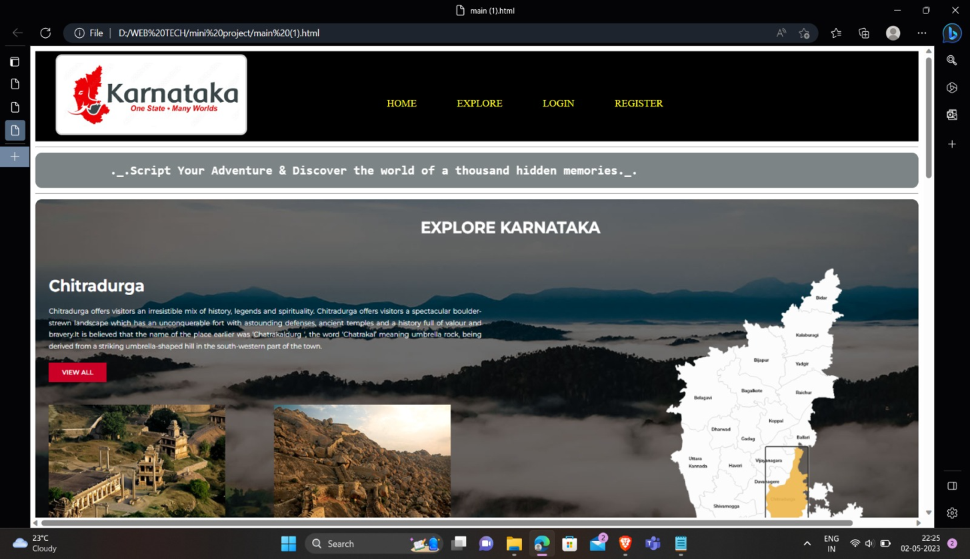

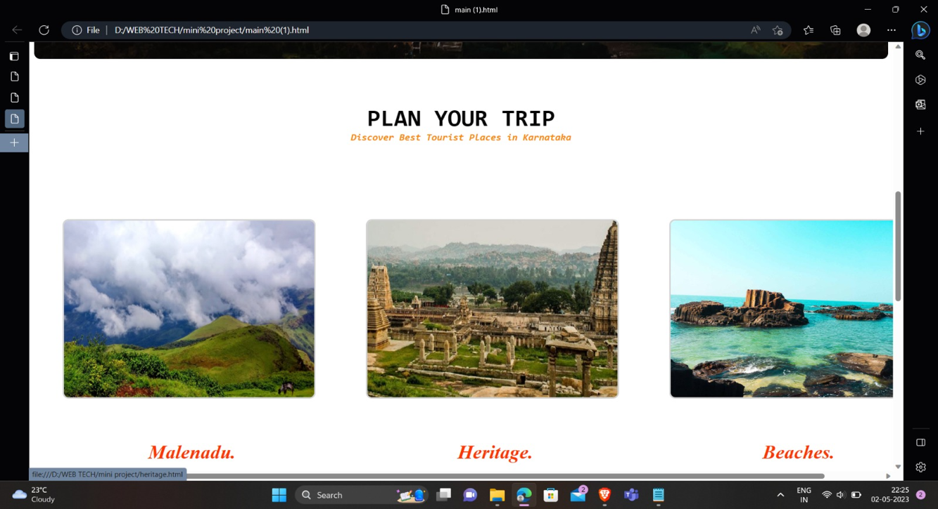

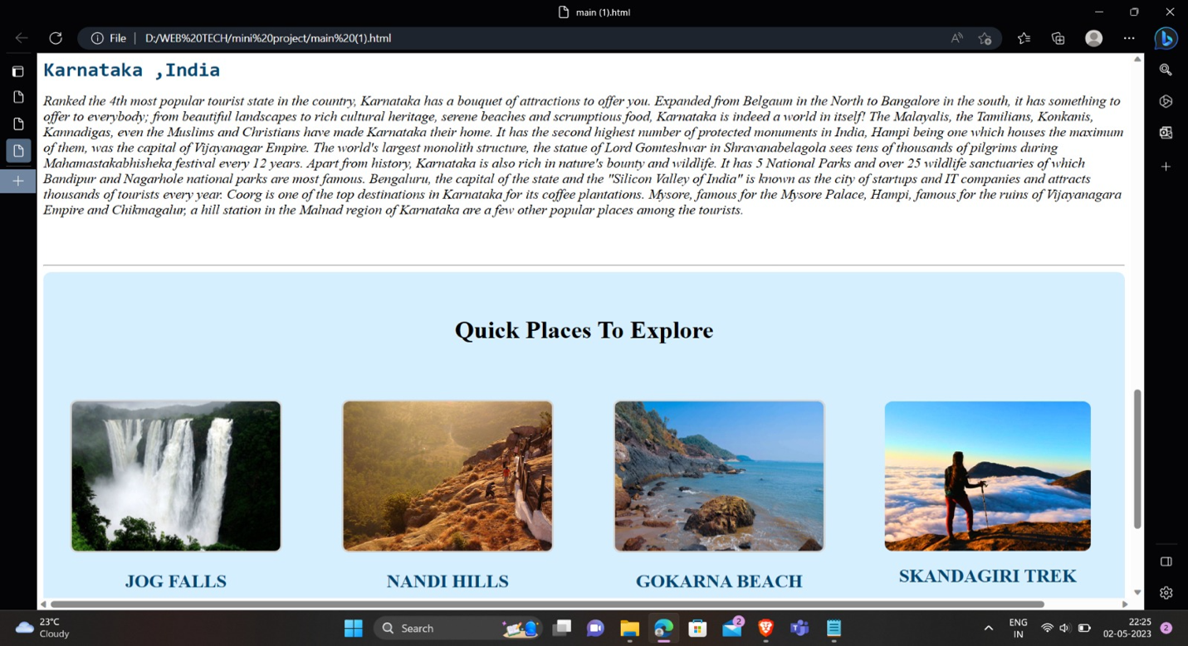

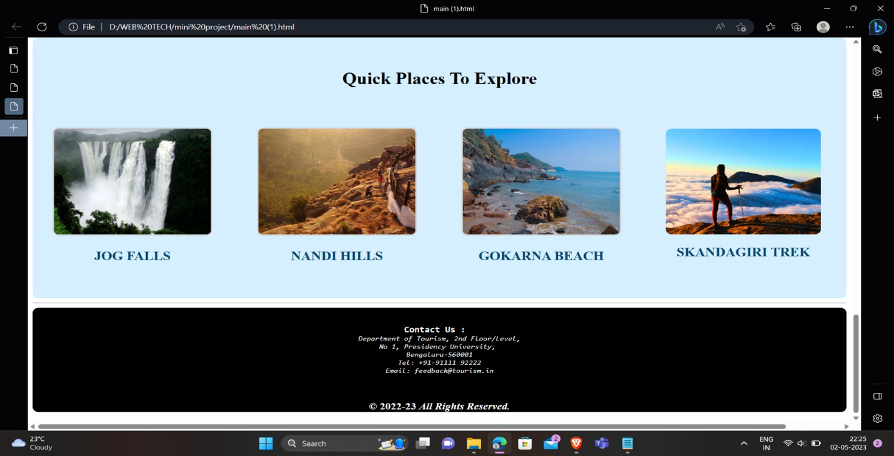

Heritage Page <html>

<body bgcolor=#000>

<style>

h3{

color:red;

font-family:Verdana;

}

ol{

color:Tomato;

font-family:Monospace;

font-size:20px;

}

img

{

border-radius:10%;

}

p{

color:gray;

text-size:5px;

font-family:Trebuchet MS;

}

</style>

<h3><marquee bgcolor='yellow' behavior='alternate' width='100%'>Welcome to the Heritage World of Karnataka</marquee></h3>

<center>

<table cellspacing='3px' cellpadding='3px' width='80%'>

<center>

<tr>

<th><a href="https://en.wikipedia.org/wiki/Pattadakal">

<img src="D:\WEB TECH\mini project\Pattadakal1.jpg" width='110%' height='105%'></th></a>

<th><a href="https://en.wikipedia.org/wiki/Badami">

<img src="D:\WEB TECH\mini project\badami2.jpg" width='60%' height='0%'></th></a>

<th><a href="https://hampi.in/stone-chariot">

<img src="D:\WEB TECH\mini project\stone.jpg" width='160%' height='180%' align='left'></th></a>

</tr>

</center>

<center>

<tr>

<td><h4 style="color:brown;font-family:Courier;" align='center'> Pattadakallu Temple </h4></td>

<td><h4 style="color:brown;font-family:Courier;" align='center'> Badami Caves </h4></td>

<center>

<td><h4 style="color:brown;font-family:Courier;" align='center'> Stone Chariot,Hampi </h4>

</center></td>

<tr>

</center>

</table>

</center><div>

<p>Karnataka is a state in southern India that has a rich and diverse cultural heritage spanning over many centuries. The state has been home to various dynasties, empires, and rulers, each of which has contributed to the state's art, architecture, and culture.

One of the most prominent periods in Karnataka's heritage is the Vijayanagara Empire, which ruled the region from the 14th to the 16th century. The empire was known for its magnificent architecture, as seen in the ruins of Hampi, a UNESCO World Heritage site. Hampi is home to numerous temples, palaces, and other structures that showcase the empire's architectural and artistic prowess.<br><br>The Hoysala Empire is another significant contributor to Karnataka's heritage, and their temples at Belur, Halebidu, and Somnathpur are famous for their intricate carvings and sculptures. The Chalukya dynasty is also known for its contributions to the state's heritage, particularly in the form of the exquisite temples of Aihole, Pattadakal, and Badami.

Apart from these, Karnataka is also known for its impressive forts and palaces, such as the Mysore Palace, the Tipu Sultan's Summer Palace, and the Chitradurga Fort. The state's art and craft traditions are also notable, with the intricate silk sarees of Mysore and the wood carvings of Channapatna being particularly famous.<br><br>Overall, Karnataka's heritage is a reflection of the state's rich history and cultural diversity. The state continues to preserve and showcase its heritage through various initiatives, such as museum exhibits, cultural festivals, and heritage walks, making it a popular destination for tourists and history enthusiasts.</p></div>

<hr size='3px'>

<h2 style="color:white;font-family:cursive"><marquee bgcolor='red'>*** Experience the Art of Sclupture ****</marquee></h2>

<h1 style="color:lightblue;font-family:Monospace;"> We Cover : </h2>

<ol><li>Badami</li>

<li>Pattadakallu</li>

<li>Aihole(The Cradel of Temples)</li>

<li>Vijayapura

<ul>

<li>The Famous Gol Gumbaz</li>

<li>Bara Kaman</li>

</li>

</ul>

<li>Hampi

<ul>

<li>Stone Chariot</li>

<li>Vittal Temple</li>

</ul>

</li>

<li>Beluru</li>

<li>Halebeedu</li>

<li>Mysure

<ul>

<li>World Famous Palace</li>

<li>Mysure Zoo</li>

</ul>

</li><center>

<table cellpadding='3px' cellspacing='2px'>

<tr>

<td><a href="http://worldfortspalaces.blogspot.com/2011/07/mysore-palacewodeyar-palace-mysore.html">

<img src="D:\WEB TECH\mini project\palace.jpg" width='60%' height='40%'></a>

</td>

</tr></table>

<h2 style="color:#A0A0A0;font-family:verdana;"> THANK YOU </h2>

</center>

</body>

</html>

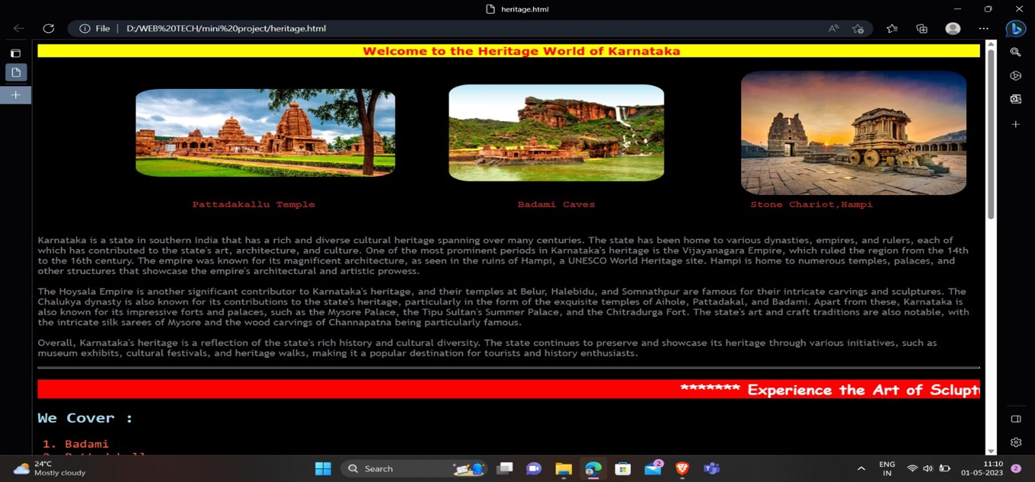

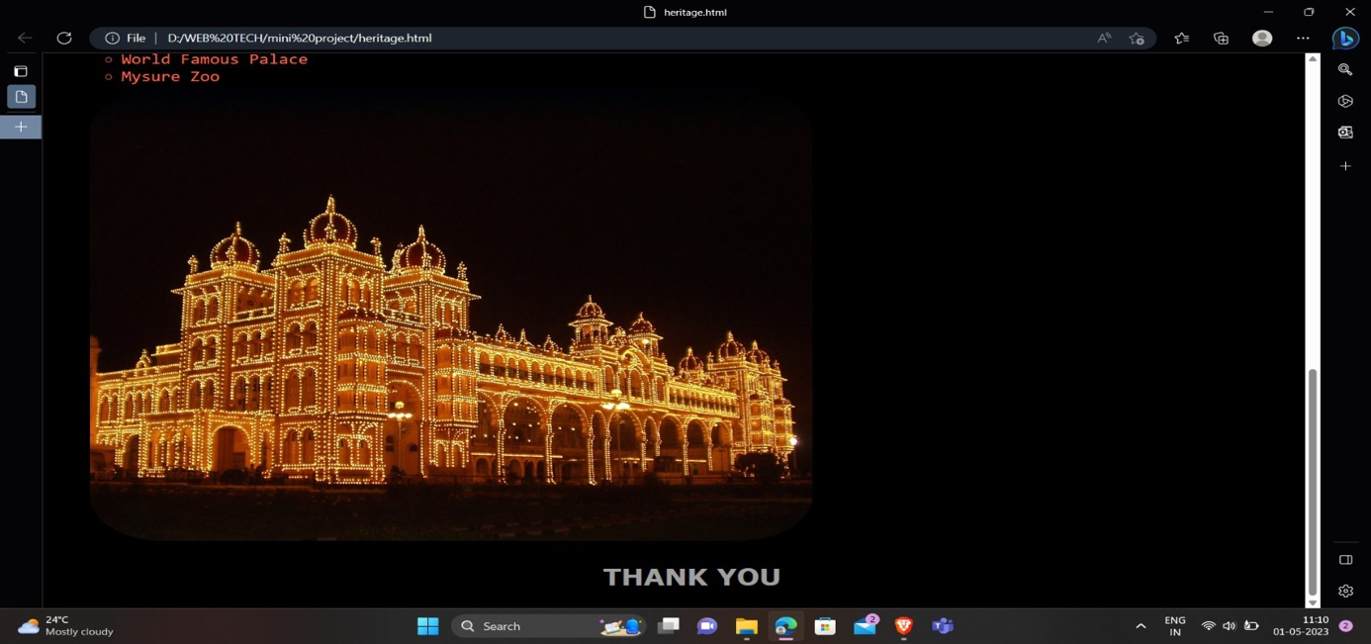

Coastal Page <html>

<head>

<style>

img

{

border-radius:5%;

}

a{

width:50%;

height:40%;

}

ol{

color:Tomato;

font-family:Monospace;

font-size:20px;

}

p{

color:gray;

text-size:5px;

font-family:Trebuchet MS;

}

</style>

</head>

<body bgcolor='black'>

<h2 style="color:red;font-family:Verdana;"><marquee behavior='alternate' bgcolor='yellow' width='100%'>Welcome to the Coastal World of Karnataka</marquee></h2><br>

<center>

<table cellspacing='3px' cellpadding='3px'>

<center>

<tr>

</tr>

<tr>

<th><a href="https://en.wikipedia.org/wiki/Murdeshwar">

<img src="D:\WEB TECH\mini project\murudeshwar.jpg" width='90%' height='40%'></th></a>

<th><a href="https://www.tripoto.com/murudeshwar/trips/want-to-see-a-glowing-beach-in-gokarna-head-over-to-this-hostel-5c6bc31760205">

<img src="D:\WEB TECH\mini project\nirvana.jpg" width='90%' height='75%'></th></a>

</tr>

</center>

<center>

<tr>

<td><h4 style="color:brown;font-family:Courier;" align='center' > Murudeshwara Beach</h4></td>

<td><h4 style="color:brown;font-family:Courier;" align='center' > Nirvana Beach </h4></td>

<tr>

</center>

</table>

</center>

<p>Karnataka's coastal region, also known as the Karavali Coast, is a popular tourist destination due to its pristine beaches, rich cultural heritage, and mouth-watering cuisine. The coastal region extends from the border of Goa in the north to the border of Kerala in the south, covering a distance of about 320 kilometers.

Some of the popular beaches in Karnataka's coastal region include Gokarna, Om Beach, Kudle Beach, and Murudeshwar Beach, which offer a range of water sports and adventure activities such as jet skiing, banana boat rides, parasailing, and snorkeling. Many of these beaches also have shacks and cafes that offer delicious seafood and local delicacies.<br><br>The coastal region is also known for its rich cultural heritage, with several ancient temples and historical landmarks. The Mahabaleshwar Temple in Gokarna, the Kukke Subramanya Temple in Mangalore, and the Udupi Sri Krishna Temple are some of the famous temples in the region. The historic forts of Kundapura, Bekal, and Basavaraja Durga are also popular tourist attractions.

The coastal region is also famous for its traditional art and craft, such as the Yakshagana and Bhoota Kola dance forms and the Kasuti embroidery. Tourists can also indulge in the local cuisine, which includes seafood delicacies, the famous Udupi cuisine, and the unique Neer Dosa and Korri Gassi dishes.<br><br>Overall, Karnataka's coastal tourism offers a unique blend of adventure, culture, and cuisine, making it a popular destination for both domestic and international tourists.</p>

<hr size='3px'>

<h2 style="color:white;font-family:cursive"><marquee bgcolor='red'>*** Come and Experience the Adventures in the Seas ****</marquee></h2>

<h1 style="color:lightblue;font-family:Monospace;"> We Cover : </h2>

<tr><center>

<td>

<a href="https://www.youtube.com/watch?v=BkS1-cCZWOI" >

<img src="D:\WEB TECH\mini project\beach4.jpg" width='50%' height='45%'></a></td>

</tr>

<br>

<br>

<br>

<br>

<tr>

<td>

<a href="https://www.youtube.com/watch?v=NmW9N7oZP2c"><img src="D:\WEB TECH\mini project\beach3.jpg" width='50%' height='45%'></a>

</td>

</tr></center>

</table>

<ol>

<li>Malpe Beach</li>

<li>Murudeshwara Beach</li>

<li>Gokarna

<ul>

<li>Om Beach</li>

<li>Kudle Beach</li>

<li>Nirvana Beach</li>

<li>Paradise Beach</li>

</ul>

<li>Maravanthe Beach</li>

<li>Tannirbaavi Beach</li>

<li>Panamburu Beach</li>

<li>Kasargodu Beach</li>

</ol>

<center>

<h3 style="color:brown;font-family:Courier;"> Saint Mary Island</h3>

<a href="https://www.youtube.com/watch?v=BReno4-02FI">

<img src="D:\WEB TECH\mini project\island.jpg" width='50%' height='40%'>

</a>

<h2 style="color:#A0A0A0;font-family:verdana;"> THANK YOU </h2>

</center>

</body>

</html>

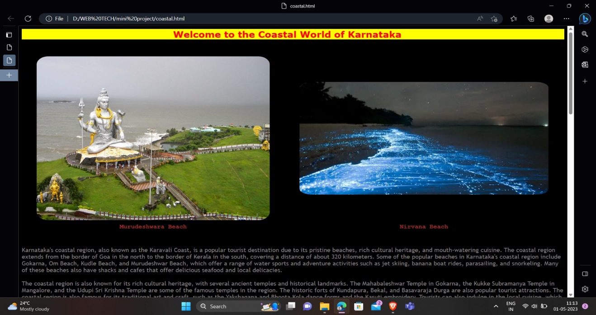

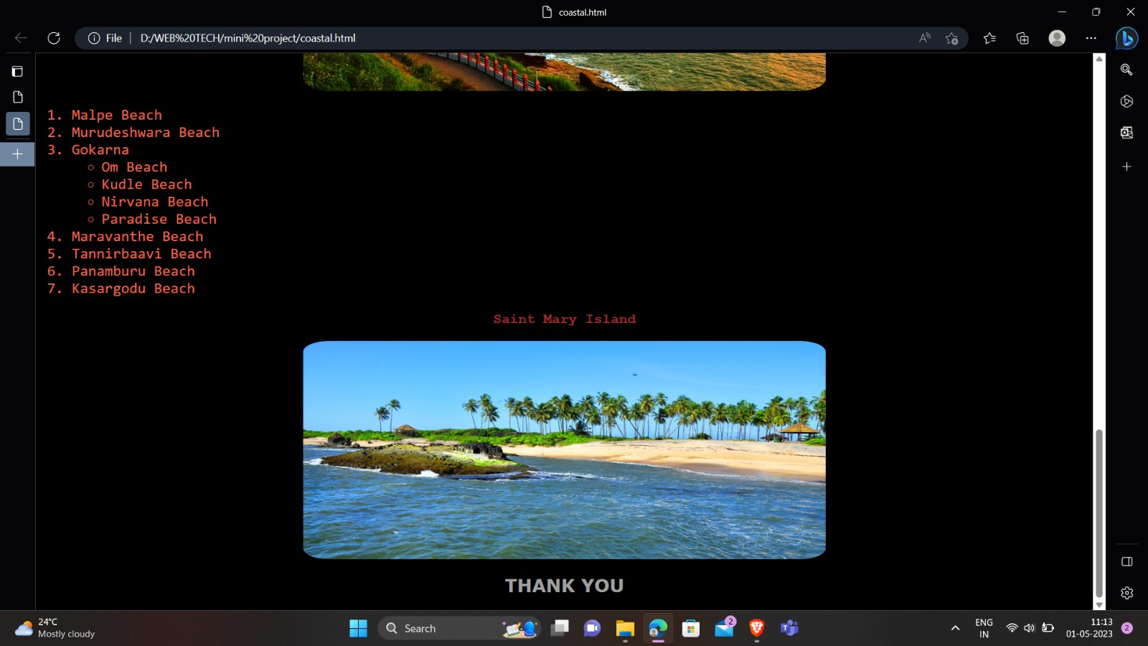

Malenadu Page <html>

<head>

<style>

img

{

border-radius:10%;

}

h3{

color:red;

font-family:Verdana;

}

ol{

color:Tomato;

font-family:Monospace;

font-size:20px;

}

p{

color:gray;

text-size:5px;

font-family:Trebuchet MS;

}

</style>

</head>

<body bgcolor='black'>

<h2 style="color:red;font-family:Verdana;"><marquee behavior='alternate' bgcolor='yellow' width='100%'>Welcome to the Land of Hills Of Karnataka</marquee></h2><br>

<center>

<table cellspacing='3px' cellpadding='3px'>

<center>

<tr>

<th><a href="https://en.wikipedia.org/wiki/Kodagu_district">

<img src="D:\WEB TECH\mini project\kodagu.jpg" width='90%' height='75%'></th></a>

<th><a href="https://en.wikipedia.org/wiki/Jog_Falls">

<img src="D:\WEB TECH\mini project\jog.jpg" width='60%' height='0%'></th></a>

<th><a href="https://en.wikipedia.org/wiki/Yana,_India">

<img src="D:\WEB TECH\mini project\YANA.jpg" width='90%' height='75%'>

</th>

</tr>

</center>

<center>

<tr>

<td><h4 style="color:brown;font-family:Courier;" align='center'> Kodagu </h4></td>

<td><h4 style="color:brown;font-family:Courier;" align='center'> Jog Falls </h4></td>

<td><h4 style="color:brown;font-family:Courier;" align='center'> Yana Caves </h4></td>

<tr>

</center>

</table>

</center>

<p>Malenadu is a region in the western part of Karnataka, nestled amidst the verdant Western Ghats. The term "Malenadu" means "land of hills" in the local language, Kannada. This region is known for its rich biodiversity, coffee plantations, and beautiful waterfalls.

The Malenadu region is characterized by its rolling hills, lush forests, and coffee and spice plantations. The region receives heavy rainfall, which makes it a haven for biodiversity. The forests in the region are home to a diverse range of flora and fauna, including rare species such as the Lion-Tailed Macaque and the Malabar Giant Squirrel.<br><br>The Malenadu region is also famous for its coffee plantations, which produce some of the finest coffee in the world. The coffee estates in the region offer a unique experience to visitors, allowing them to witness the entire process of coffee production, from picking the coffee berries to roasting and packaging.

The region is also home to several waterfalls, which attract tourists from across the country. Jog Falls, the second-highest plunge waterfall in India, is a major tourist attraction. Other famous waterfalls in the region include Abbey Falls, Hebbe Falls, and Sirimane Falls. The Malenadu region is also known for its traditional art and culture. The Yakshagana dance form, unique to the region, is a vibrant blend of music, dance, and drama. The region also has a rich culinary tradition, with local dishes such as Akki Rotti, Kadubu, and Bisi Bele Bath being popular.<br><br>Overall, the Malenadu region of Karnataka offers a serene and tranquil environment, with its lush forests, coffee plantations, and beautiful waterfalls. The region's unique art, culture, and cuisine add to the overall experience, making it a must-visit destination for tourists.</p>

<hr size='3px'>

<h2 style="color:white;font-family:cursive"><marquee bgcolor='red'>*** Explore the Beautiful Hills and Falls ****</marquee></h2>

<h1 style="color:lightblue;font-family:Monospace;"> We Cover : </h2>

<ol>

<li>Shivamogga

<ul>

<li>Jog Falls</li>

<li>Aagumbe</li>

<li>Mandagadde Bird Sanctuary</li>

</ul></li>

<li>Chikkamagaluru

<ul>

<li>Kuduremukha</li>

<li>Mullayyanagiri Betta</li>

<li>Baba Budan Giri(Datta Peetha)</li>

<li>Kemmannu Gundi</li>

<li>Hebbe Falls</li></ul></li>

<li>Madikeri<ul>

<li>Raja's Seat</li>

</ul></li>

<li>Uttara Kannada

<ul><li>Mirjan Fort</li>

<li>Dandeli Wildlife Sanctuary</li>

</ul></li>

<li>Udupi

<ul><li>Kudlu Theertha Falls</li>

<li>Kodachadri</li>

</ul></li>

<li>Dakshina Kannada

<ul><li>Kumara Parvatha</li>

<liAbbey Falls</li>

</ul></li>

<li>Belagavi

<ul>

<li>Rajahansagad</li>

<li>Ambuli Ghat</li>

<li>Ambuli Falls</li>

</ul></li>

</ol>

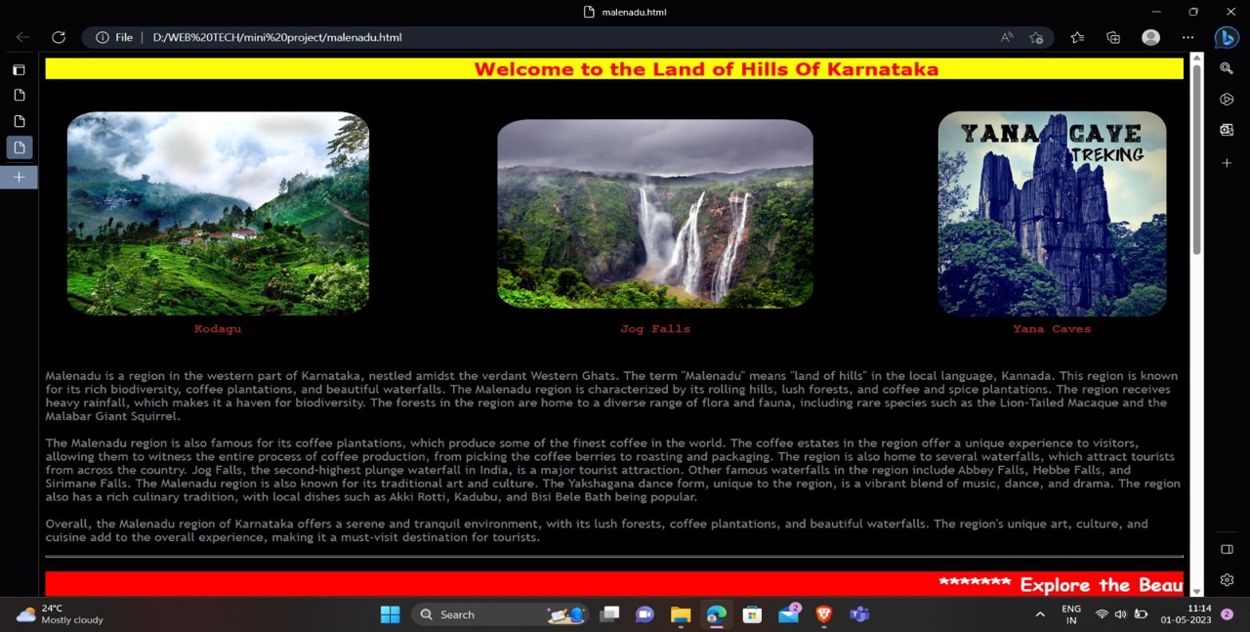<center>

<a href="https://youtube.com/shorts/3FB7A_vTlKM?feature=share">

<img src="D:\WEB TECH\mini project\mfalls.jpg" width='30%' height='80%'></a>

<h2 style="color:#A0A0A0;font-family:verdana;"> THANK YOU </h2></center>

</body>

</html>

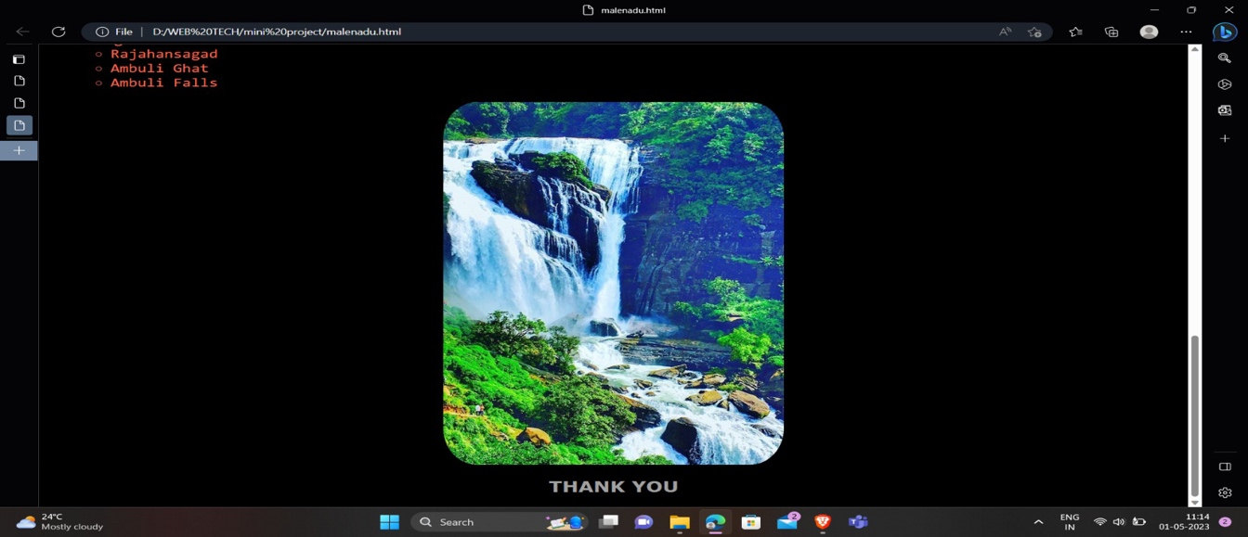

Registration page

<html>

<head>

<title>Registeration</title>

<style>

td{

font-family:verdana;

text-size:7px;

text-transform:uppercase;

}

</style>

</head>

<body bgcolor="#D5EFFF">

<center>

<img src='chik.png' width='65%' height='50%'>

<h2 style="color:dodgerblue;font-family:verdana;

text-size:25px;">*** Register Yourself Here ***</h2></center>

<hr>

<center>

<table cellspacing='10px' cellpadding='5px'>

<tr>

<td><label for='fname'>First Name : </label></td>

<td><input type="text" id='fname'></td>

</tr>

<tr>

<td><label for='lname'>Last Name : </label></td>

<td><input type="text" id='lname'></td>

</tr>

<tr>

<td><label for='pno'>Phone Number : </label></td>

<td><input type="tel" id='pno'></td>

</tr>

<tr>

<td><label for='email'>Email Address : </label></td>

<td><input type="Email" id='email'></td>

</tr>

<tr>

<td><label for='dob'>Date-Of-Birth : </label></td>

<td><input type="date" id='dob'></td>

</tr>

<tr>

<td><label for='age'>Age : </label></td>

<td><input type="number" id='age'></td>

</tr>

<tr>

<td><label for='adr'>Residential Address : </td>

<td><textarea rows='5' cols='30'></textarea></td>

</tr>

<tr>

<td><label for='state'>State : </label></td>

<td><input type="text" id='state'></td>

</tr>

<tr>

<td><label for='country'>Country : </label></td>

<td><input type="text" value="INDIA"></td>

</tr>

<tr>

<td><label for='gen'>Gender : </label></td>

<td><input type="radio" name="gender">Male </td>

<td><input type="radio" name="gender">Female </td>

</tr>

</table>

<br><br>

<input type="submit" value='Submit'>&nbsp;&nbsp;&nbsp;&nbsp;&nbsp;&nbsp;

<input type="Reset" value='Reset'>

</center>

</body>

</html>

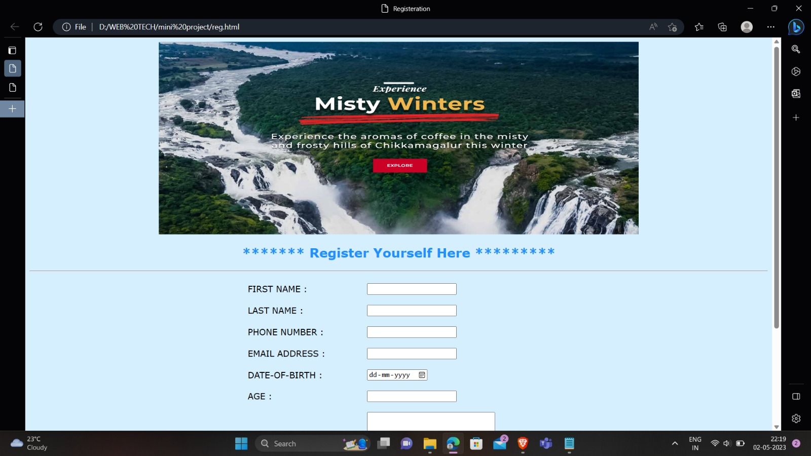

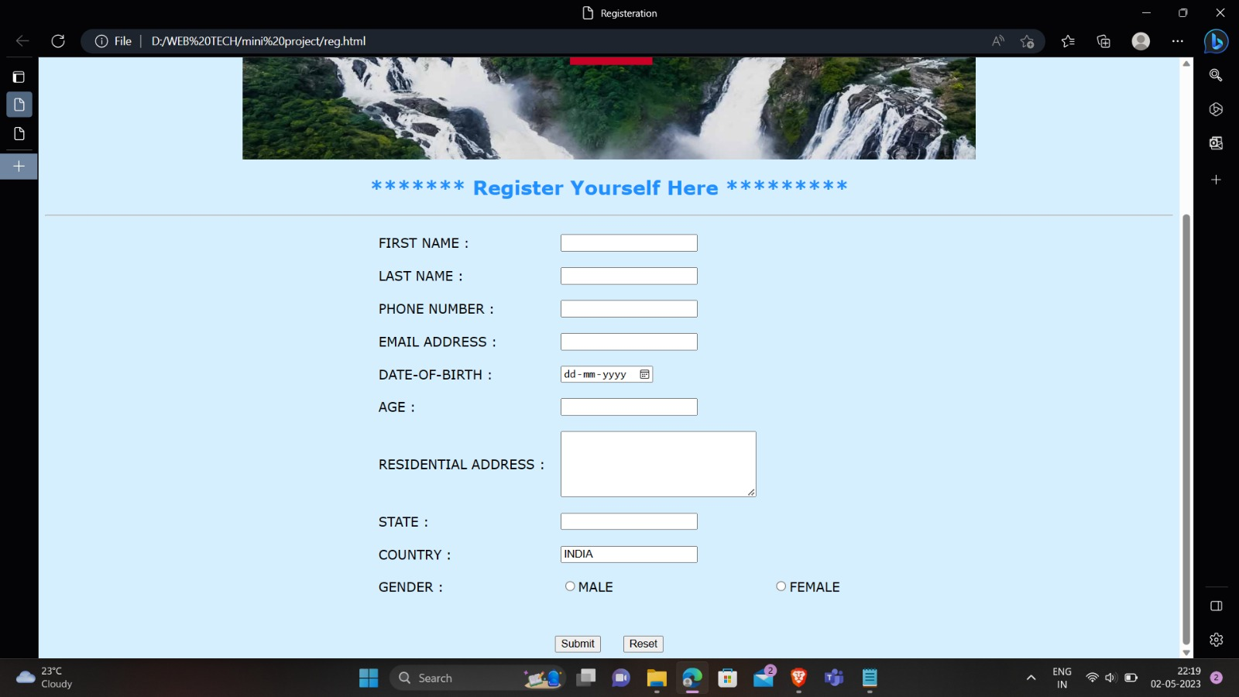

Login Page

<html>

<head>

<style>

big{

color:red

}

td

{

text-transform:uppercase;

font-family:verdana;

}

h1

{

text-transform:uppercase;

font-family:verdana;

color:dodgerblue;

}

a

{

text-transform:uppercase;

font-family:verdana;

color:dodgerblue;

text-size:5px;

}

p

{

text-transform:uppercase;

font-family:verdana;

color:black;

text-size:2px;

}

</style>

<title>

login</title></head>

<body bgcolor="lightyellow">

<center><h1>Welcome All to my Website</h1></center>

<marquee><p>Login if you are an old member else you can sign-in and and register yourself ,so that we can keep you updated.</marquee>

<hr color="blue">

<center>

<table cellspacing='10px' cellpadding='5px'><tr>

<td><label for='login'>Login email : </label></td>

<td><input type="email" id='login'></td>

</tr>

<tr>

<td><label for='pass'>Passward : </label></td>

<td><input type="password" id='pass'></td>

</tr>

</table>

<input type="submit" value='SUBMIT' style='color:red;'>&nbsp;&nbsp;&nbsp;&nbsp;&nbsp;&nbsp

<input type="reset" value='RESET' style='color:red;'><br><br>

<a href="reg.html">Sign Up</a><br><br>

<img src='hampi1.png' width='60%' height='60%'>

</center></body><html>

